**CAPSTONE PROJECT**

**HandsMen Threads: Elevating the Art of Sophistication in Men's Fashion**

**Use Case:**

HandsMen Threads, a dynamic organization in the fashion industry, is embarking on a Salesforce project designed to revolutionize their data management and enhance customer relations. The project involves building a robust data model tailored to store all pertinent business data, ensuring a seamless flow of information across the organization.

A key aspect of this project is the maintenance of data integrity directly from the user interface (UI). This feature will safeguard the accuracy and consistency of the data, which is crucial for informed decision-making and reliable business operations.The project will integrate several new processes into the business workflow to improve customer service and operational efficiency:

Automated Order Confirmations: Post-order confirmation, customers will receive an email update, fostering engagement and strengthening customer relations.

Dynamic Loyalty Program: Customer loyalty statuses will be updated based on purchase history, enabling personalized rewards and promoting repeat business.

Proactive Stock Alerts: When stock levels drop below five units, automatic emails will notify the warehouse team, ensuring timely restocking and preventing stockouts.

Scheduled Bulk Order Updates: Daily midnight, the system will process bulk orders, updating financial records and adjusting inventory, ensuring accurate stock levels for daily operations.

**Description:**

Developing a premium fashion platform to streamline men’s bespoke tailoring and enhance customer experience through personalized styling and seamless order management.

**Key Features**

* User Profile & Measurement Storage
* AI-Based Style Recommendations
* Tailor Dashboard for Order Management
* Live Chat with Style Advisors
* Fabric & Design Selection Interface
* Order Tracking System

**Technology Stack**

* Frontend: ReactJS / Flutter (if mobile)
* Backend: Node.js / Django
* Database: Firebase / MySQL
* Authentication: Firebase Auth / OAuth
* Cloud Services: AWS / Google Cloud
* Version Control: GitHub

**Custom objects and their fields:**

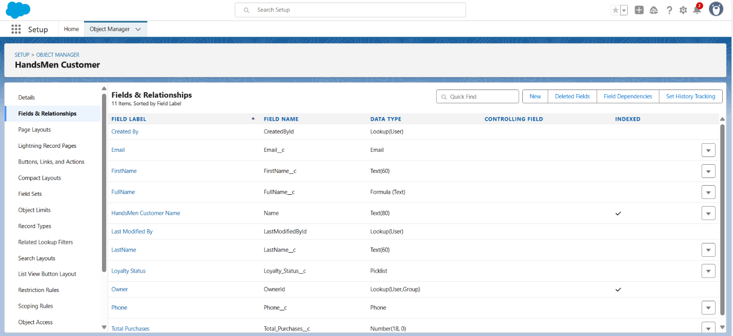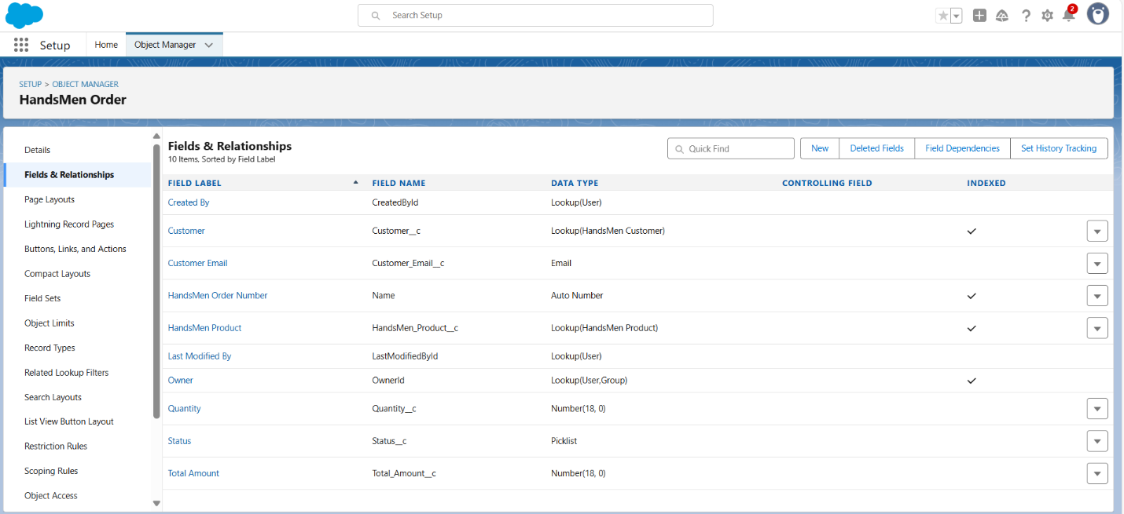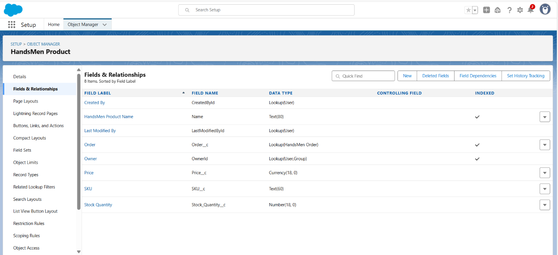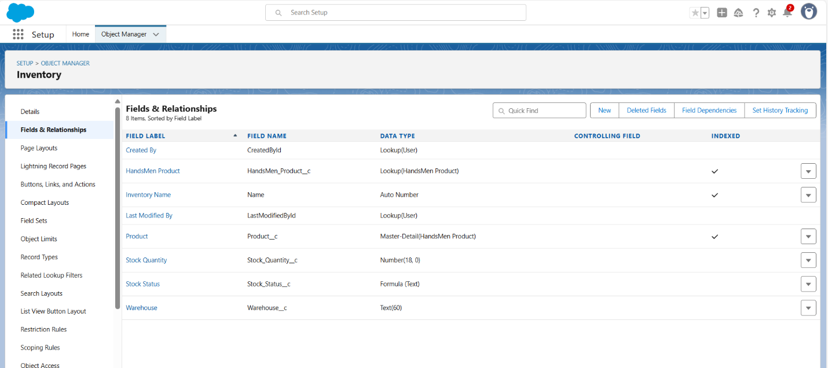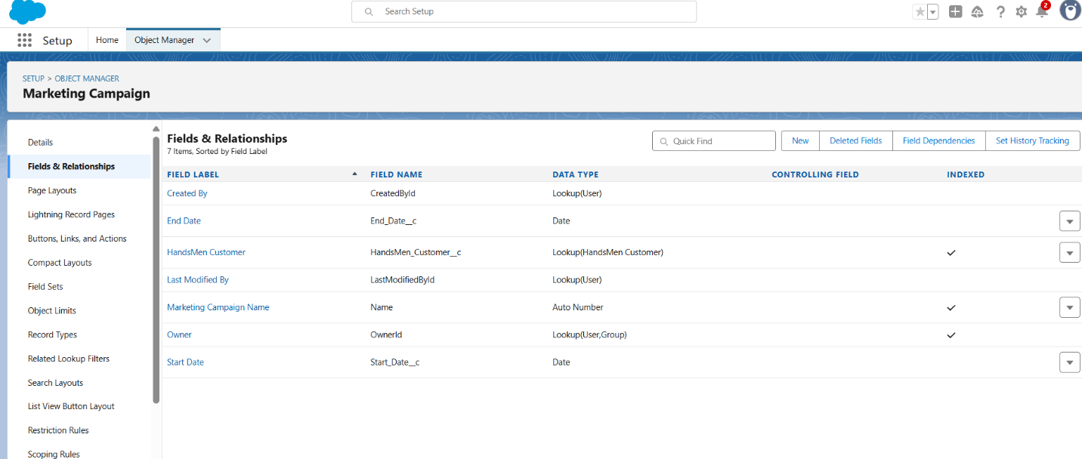

**User Flow Diagram**

1. **New user visiting the site**
2. **Creating a profile and adding measurements**
3. **Selecting a garment**
4. **Placing an order**
5. **Tracking status**

**Order Confirmation Flow:**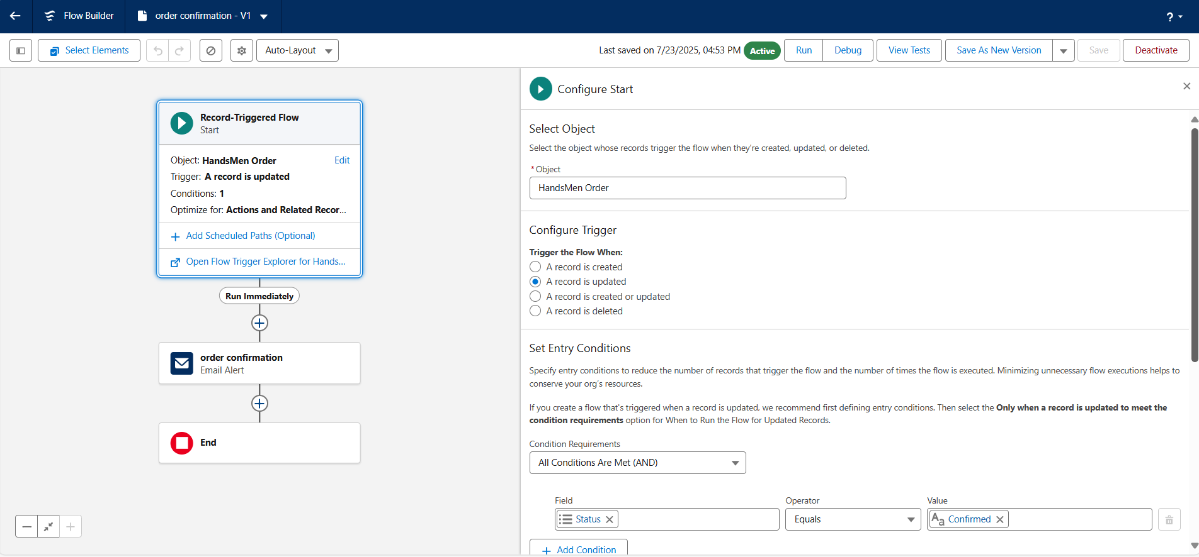

**Loyalty Program email Flow: 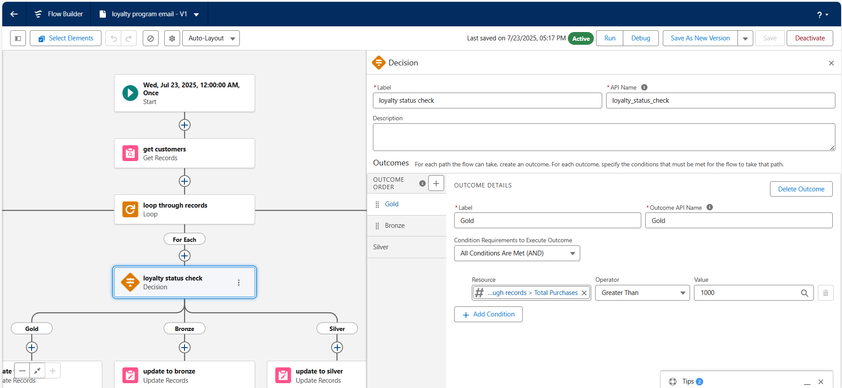Low Stock alert Flow:**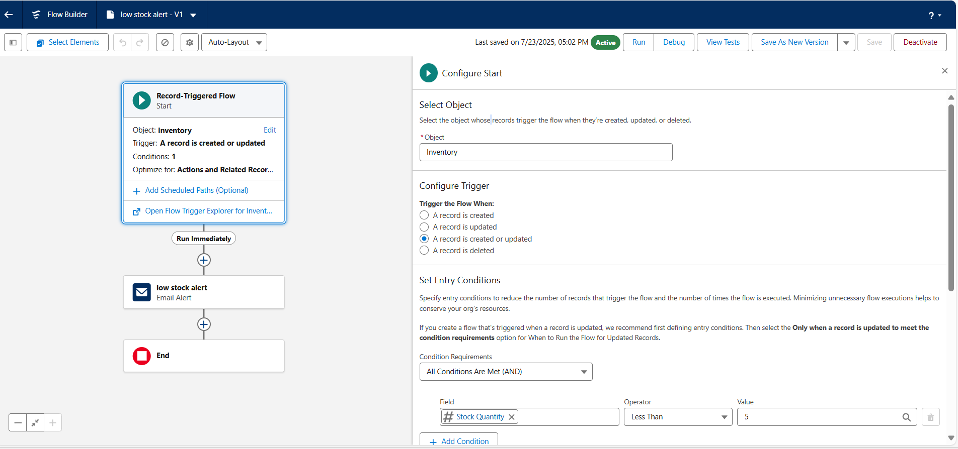

**App-Handsmen Threads:**

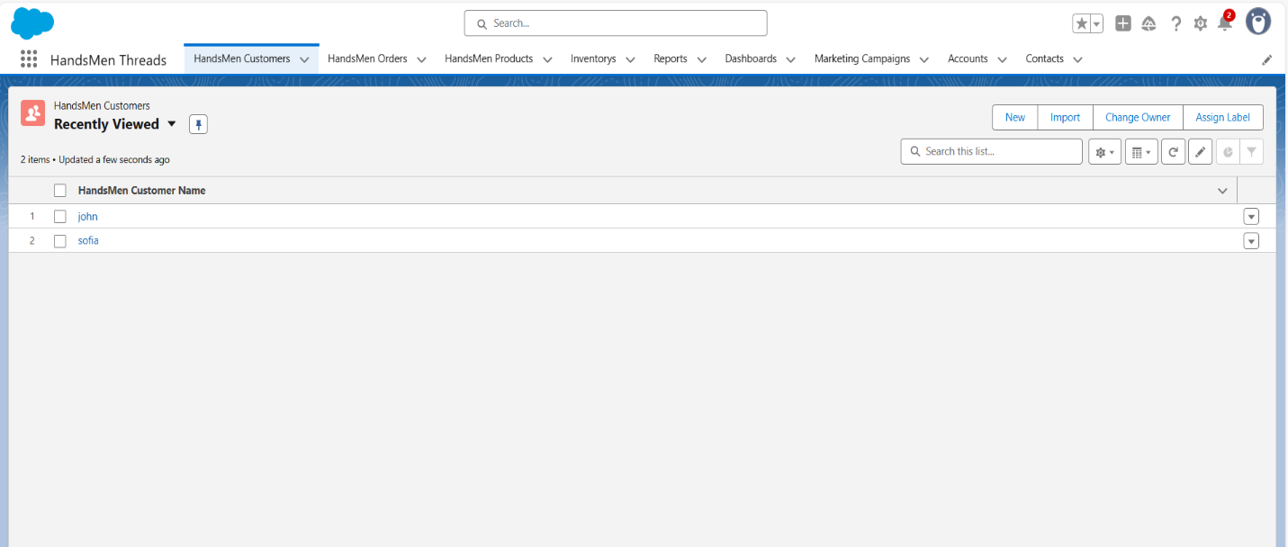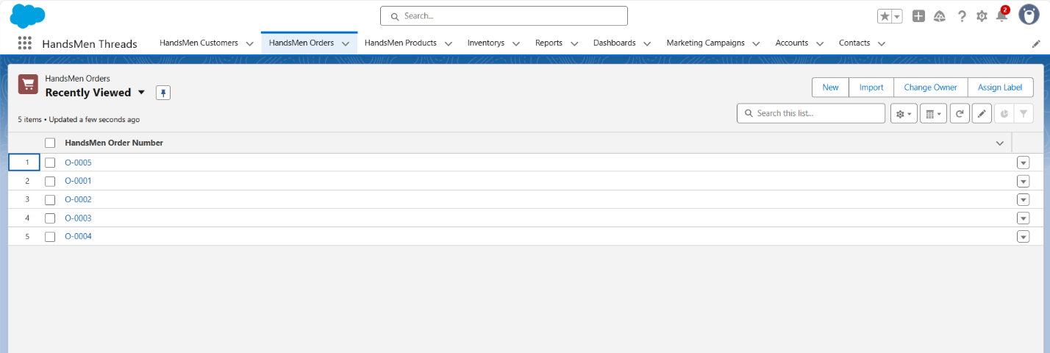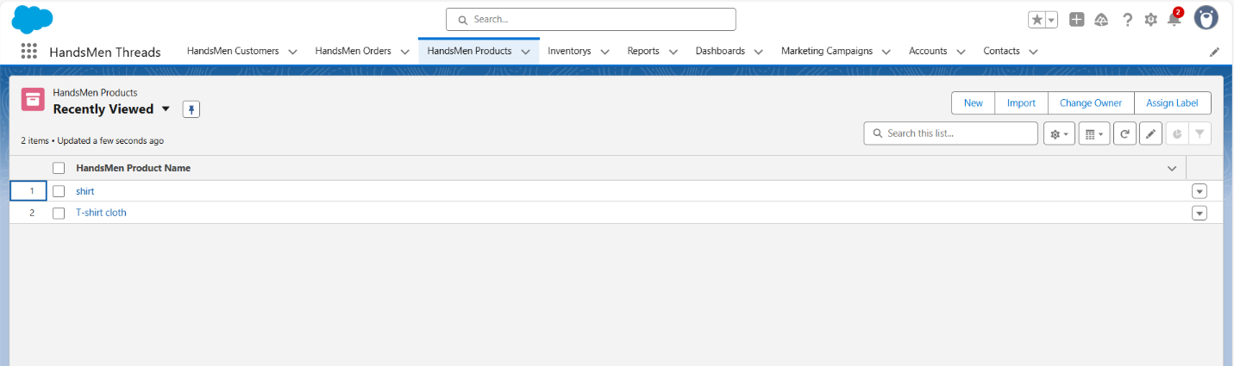

**Data Management Fields:**

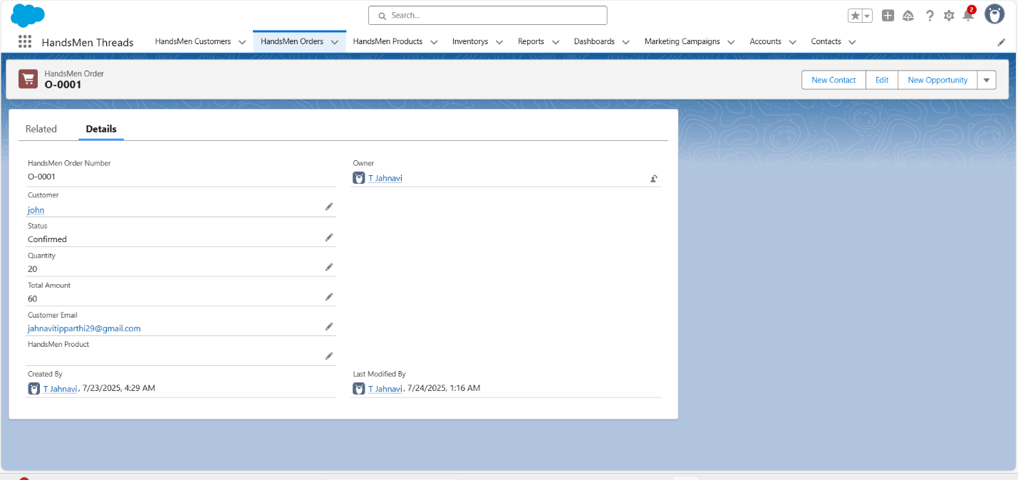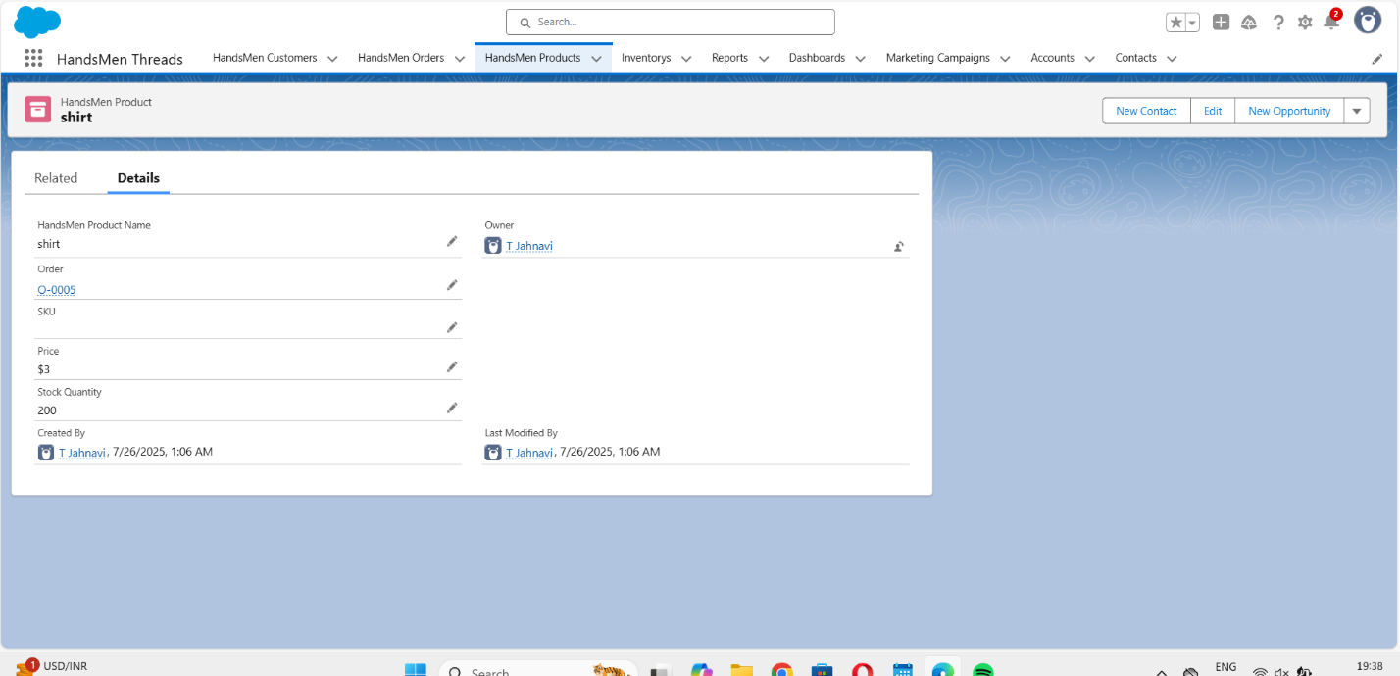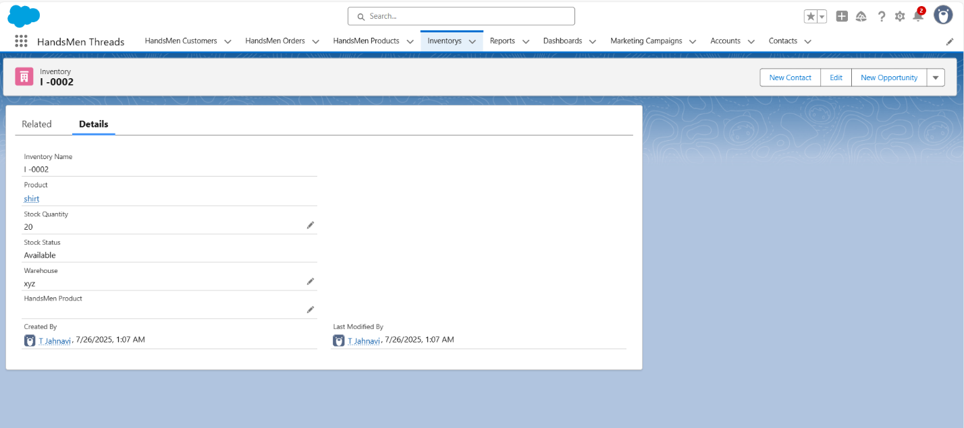

**Email alerts:**

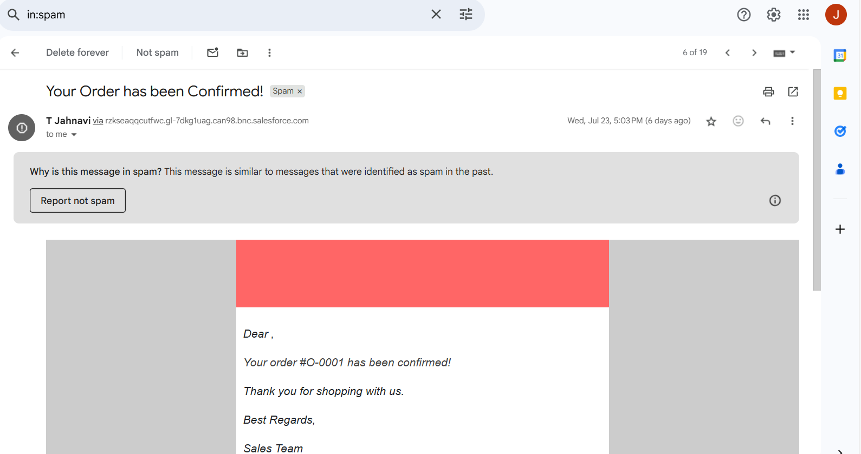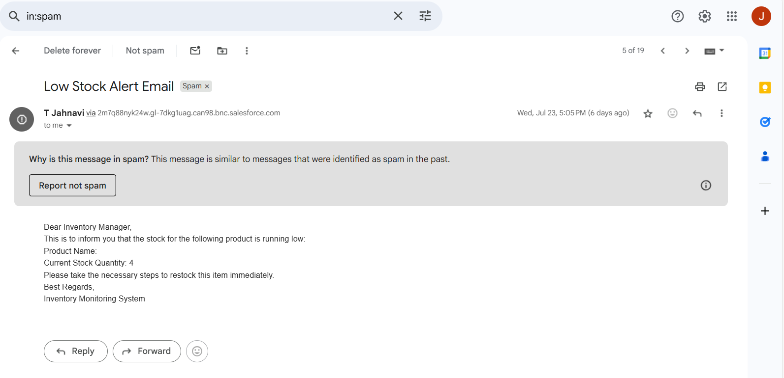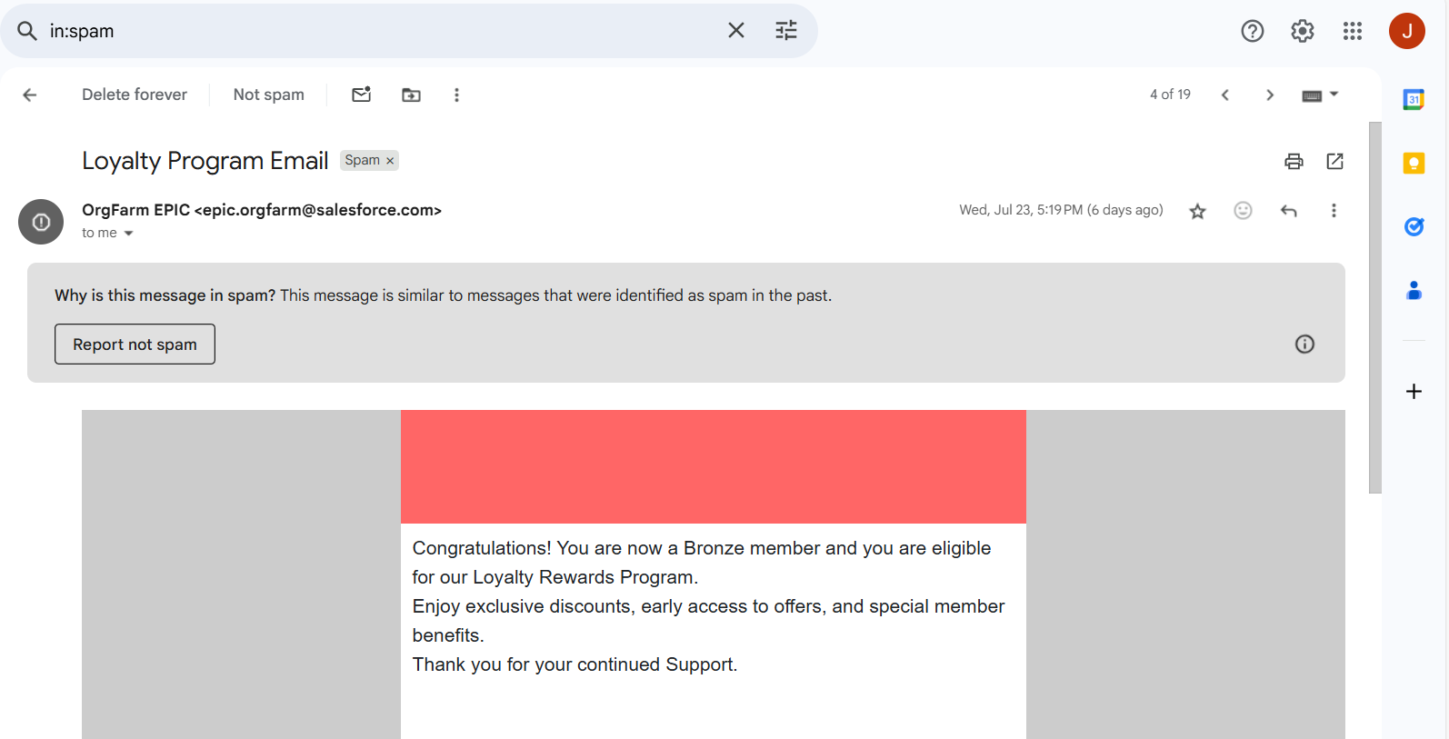

**Apex code:**

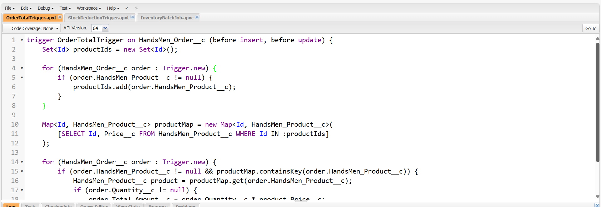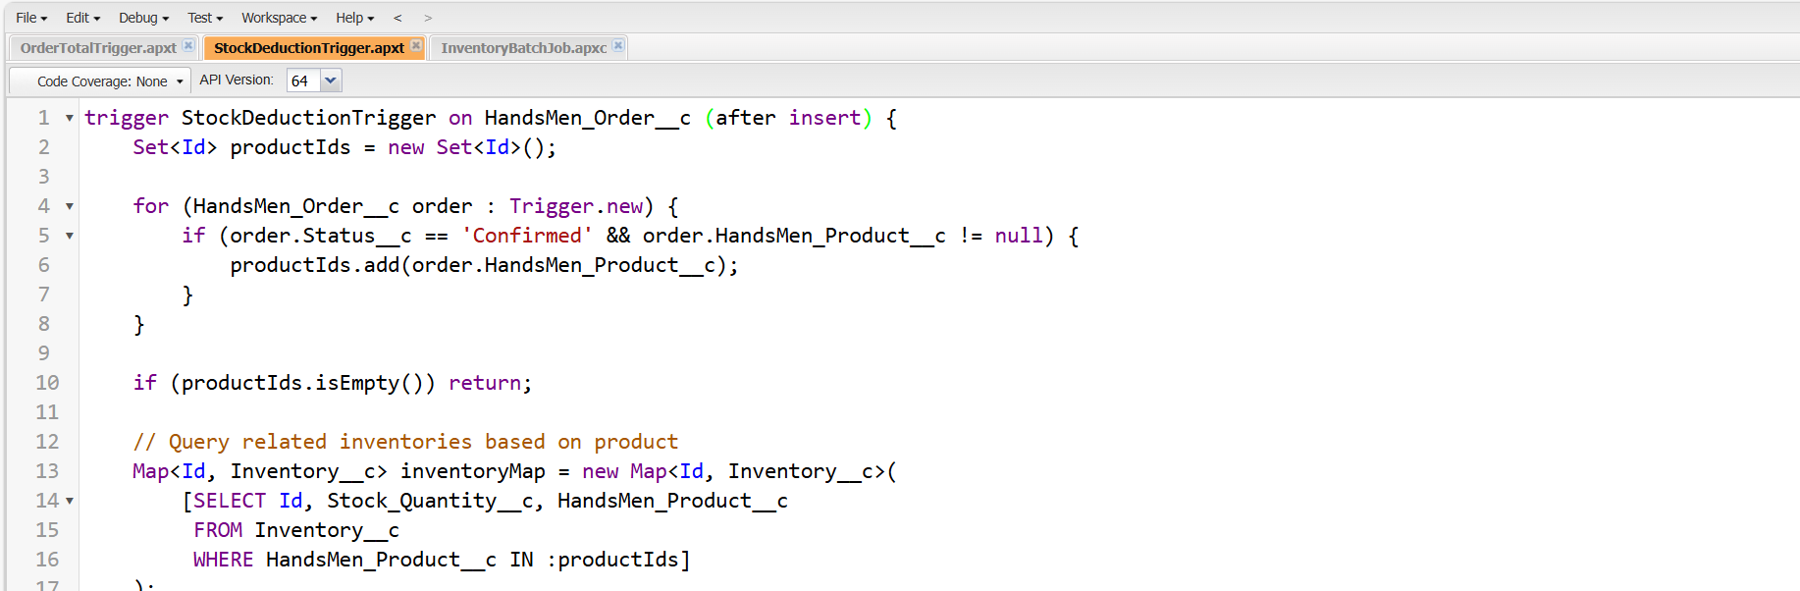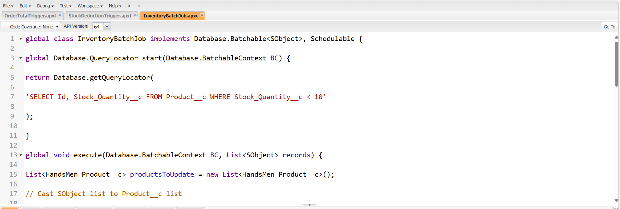

**CONCLUSION:**

HandsMen Threads stands as a transformative innovation in men’s fashion, seamlessly blending traditional bespoke tailoring with modern digital convenience. By integrating personalized styling, real-time order management, and a user-friendly interface, the platform ensures a premium experience for every customer. The architecture ensures secure, scalable, and efficient operations, supporting both end users and tailoring professionals. From fabric selection to final delivery, every step is streamlined for sophistication and efficiency. This project not only enhances the tailoring experience but also paves the way for future innovations in fashion tech, positioning HandsMen Threads as a pioneer in luxury men’s digital fashion services.